Project Design Phase-II
Solution Requirements (Functional & Non-functional)

Date | 25-06-2026
Team ID | 23A51A4441
Project Name | Metro Ticket Generating System in ServiceNow
Maximum Marks | 4 Marks

Functional Requirements:
FR No. | Non-Functional Requirement | Description
NFR-1 | Usability | The system should provide a simple, intuitive, and user-friendly interface that allows passengers to book metro tickets easily without technical knowledge.
NFR-2 | Security | The system should ensure secure access through authenticated user accounts, role-based access controls, and secure data transmission using HTTPS protocols.
Following are the functional requirements of the proposed solution.
FR No. | Functional Requirement (Epic) | Sub Requirement (Story / Sub-Task)
FR-1 | Metro Ticket Booking | Select Source Station  Select Destination Station  Choose Journey Date  Enter Number of Passengers
FR-2 | Fare Calculation | Calculate Fare Based on Route  Display Fare per Passenger  Calculate Total Fare Automatically
FR-3 | Ticket Request Submission | Submit Metro Ticket Request  Generate Request Number (REQ)  Generate Requested Item (RITM)
FR-4 | Ticket Confirmation | Display Booking Confirmation  Show Ticket Details  Provide Ticket Reference Number
FR-5 | Notification Management | Send Booking Confirmation Email  Send Ticket Details to User  Notify Successful Booking
FR-6 | Digital Ticket Generation | Generate Digital Ticket  Create QR Code for Ticket  Attach QR Code to Ticket

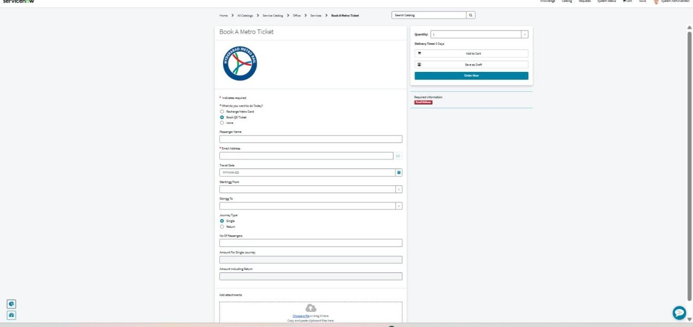
Fig: Metro Ticket Booking Form (Service Catalog) implementing the functional requirements above
Non-functional Requirements:
Following are the non-functional requirements of the proposed solution.
NFR-3 | Reliability | The system should consistently generate accurate fare calculations confirmations with minimal errors or downtime.
NFR-4 | Performance | The system should calculate fares, process ticket bookings, and generate confirmations within a few seconds to provide a smooth user experience.
NFR-5 | Availability | The application should be accessible 24×7 through the ServiceNow availability to users.
NFR-6 | Scalability | The system should support an increasing number of users, ticket bookings, and metro routes without significant degradation in performance.

